|  |
| --- |
| 18/07/2016 |

|  |
| --- |
| **[ rpmBIMTools Utility Guide ]** |
| This guide will give instructions on how to install this add-in as well and how each utility is used and how it can assist and improve in work productivity with NG Bailey. |

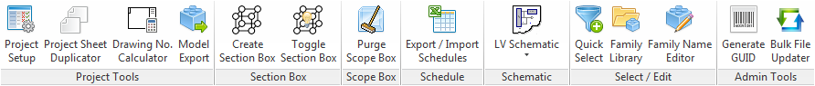

Contents

[Installation 2](#_Toc456622197)

[Requirements 2](#_Toc456622198)

[Setup 2](#_Toc456622199)

[Utilities 2](#_Toc456622200)

[Project Setup 3](#_Toc456622201)

[Project Sheet Duplicator 4](#_Toc456622202)

[Drawing Number Calculator 5](#_Toc456622203)

[Model Export 9](#_Toc456622204)

[Create Section Box 10](#_Toc456622205)

[Toggle Section Box 11](#_Toc456622206)

[Purge Scope Box 12](#_Toc456622207)

[Export / Import Schedules 13](#_Toc456622208)

[Create LV Schematic 15](#_Toc456622209)

[Import LV Schematic 15](#_Toc456622210)

[Export LV Schematic 15](#_Toc456622211)

[Quick Select 16](#_Toc456622212)

[Family Library 17](#_Toc456622213)

[Family Name Editor 19](#_Toc456622214)

[Generate GUID 21](#_Toc456622215)

[Bulk File Updater 21](#_Toc456622216)

[Ribbon Extensions 21](#_Toc456622217)

[Additional Resources 22](#_Toc456622218)

[Video Tutorials 22](#_Toc456622219)

[Github 22](#_Toc456622220)

[Developer API Calls 22](#_Toc456622221)

# Installation

### Requirements

rpmBIMTools requires the following software to be installed in order to function correctly:

* rpmBIM Installed.
* Microsoft .NET 4.5.1 or higher installed.
* Revit 2015, 2016 or 2017 installed.

### Setup

The Below example is for Revit 2015, please change the year for what version of Revit you are installing for.

1. Copy ‘***rpmBIMTools2015.addin***’ from the following folder:  
   [C:\rpmBIM\progs\](file:///C:\rpmBIM\progs\)  
   to the following folder:  
   [C:\ProgramData\Autodesk\Revit\Addins\2015\](file:///C:\ProgramData\Autodesk\Revit\Addins\2015\)

# Utilities

Below is a list of all the utilities current functioning under the rpmBIMTools addin.

* Project Setup
* Project Sheet Duplicator
* Drawing Number Calculator
* Model Export
* Create Section Box
* Toggle Section Box
* Purge Scope Box
* Export / Import Schedules
* LV Schematic
* Quick Select
* Family Library
* Family Name Editor Generate GUID
* Bulk File Updater

This section will cover each of these utility in detail, explaining how they function and how they will assist in productivity.

### Project Setup

### C:\Users\coxm\Desktop\rpmBIMTools Guide\Project Sheet Duplicator.pngProject Sheet Duplicator

1. *Master Sheet List*
2. *View Template List*
3. *Utility Controls*  
     
   *Add Legends to Sheets* – Checking this will allow for the creation or add adding of legends for every sheet that is produced from the utility.  
     
   *Duplicate Button* – Starts the duplication process. Requires at least one master drawing within the active project to begin.  
     
   *Cancel Button* – Closes the utility, the ESC key is linked to this button.

### Drawing Number Calculator

The drawing Number Calculator utility is used to conform to the Bailey standard using the predefined fields and controls with the ability to output the drawing number in multiple ways.

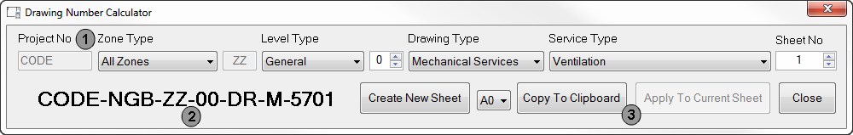

|  |  |
| --- | --- |
| Zone Type | Modifier |
| All Zones | ZZ |
| Zone | Z# |
| Riser | R# |
| Custom | ## |

1. *Calculation Fields  
     
   Project Number – This field is automatically filled based on the project number in project information of the active Revit project.  
     
   Zone Type – This field has a set of predefined value modifications that set part of the calculated drawing number, they are as follows:  
     
     
     
     
     
     
   # = based on custom input field to the right of zone type field  
     
   Level Type – This field has a set of predefined value modifications that set part of the calculated drawing number, they are as follows:*

|  |  |
| --- | --- |
| Level Type | Modifier |
| General | 0# |
| Basement | B# |
| Mezzanine | M# |
| Multiple Levels | ## |
| External | EX |
| Not Applicable | XX |

*# = based on custom input field to the right of level type field*

*Drawing Type and Service Type – Both of these fields work together to give the user the predefined value modifications that set part of the calculated drawing number, they are as follows:*

|  |  |  |
| --- | --- | --- |
|  | Service Type | Modifier |
| Treatment Drawings | Spare (M10) | M-10 |
| Spare (M11) | M-11 |
| Drainage | M-12 |
| Domestic | M-13 |
| Gas / Compressed Air / Medical Gas | M-14 |
| Chilled Water / Refrigeration | M-15 |
| Heating | M-16 |
| Ventilation | M-17 |
| Spare (M18) | M-18 |
| Fire Engineering | M-19 |
| Main HV Distribution | E-20 |
| Main LV Distribution | E-21 |
| Small Power | E-22 |
| Lighting | E-23 |
| CCTV / TV | E-24 |
| Communications | E-25 |
| Containment | E-26 |
| Fire Alarm | E-27 |
| Security / Access Control | E-28 |
| Lightning Protection / Earthing | E-29 |
| Schematics | Spare (M30) | M-30 |
| Spare (M31) | M-31 |
| Drainage | M-32 |
| Domestic | M-33 |
| Gas / Compressed Air / Medical Gas | M-34 |
| Chilled Water / Refrigeration | M-35 |
| Heating | M-36 |
| Ventilation | M-37 |
| Spare (M38) | M-38 |
| Fire Engineering | M-39 |
| Main HV Distribution | E-40 |
| Main LV Distribution | E-41 |
| Small Power | E-42 |
| Lighting | E-43 |
| CCTV / TV | E-44 |
| Communication | E-45 |
| Containment | E-46 |
| Fire Alarm | E-47 |
| Security / Access Control | E-48 |
| Lightning Protection / Earthing | E-49 |

|  |  |  |
| --- | --- | --- |
|  | Service Type | Modifier |
| Mechanical Services | Spare (M50) | M-50 |
| Spare (M51) | M-51 |
| Drainage | M-52 |
| Domestic | M-53 |
| Gas / Compressed Air / Medical Gas | M-54 |
| Chilled Water / Refrigeration | M-55 |
| Heating | M-56 |
| Ventilation | M-57 |
| Spare (M58) | M-58 |
| Fire Engineering | M-59 |
| Electrical Services | Main HV Distribution | E-60 |
| Main LV Distribution | E-61 |
| Small Power | E-62 |
| Lighting | E-63 |
| CCTV / TV | E-64 |
| Communications | E-65 |
| Containment | E-66 |
| Fire Alarm | E-67 |
| Security / Access Control | E-68 |
| Lightning Protection / Earthing | E-69 |
| Coordinated Services | Coordinated Layout | M-70 |
| Coordinated Sections | M-71 |
| Coordinated Details | M-72 |
| Spare (M73) | M-73 |
| Spare (M74) | M-74 |
| Builderswork Services | Builderswork Layout | M-75 |
| Builderswork Sections | M-76 |
| Builderswork Details | M-77 |
| Spare (M78) | M-78 |
| Spare (M79) | M-79 |
| Details & Sections | General Details & Sections | M-80 |
| Electrical Details & Sections | E-81 |
| Drainage | M-82 |
| Domestic | M-83 |
| Gas / Compressed Air / Medical Gas | M-84 |
| Chilled Water / Refrigeration | M-85 |
| Heating | M-86 |
| Ventilation | M-87 |
| Spare (M88) | M-88 |
| Spare (M89) | M-89 |
| Offsite Drawings | Spool Drawings | M-90 |
| Module Drawings | M-01 |
| Prefab Plantroom | M-02 |
| Riser | M-03 |
| Distribution Boards | M-04 |
| Master | Master Drawings | #-## |

C:\Users\coxm\Desktop\rpmBIMTools Guide\Notification_Information.png*Sheet Number* – Field modification that changes the ending of the drawing number generated, this can be from 0 to 99 (999 if it’s an offsite spool drawing). *When any of the above fields are changed the drawing number preview label will be updated to reflect the changes.*

1. *Drawing Number Preview* – This text label will display the current drawing number based on the user selections made with the calculator fields on the top row.
2. *Utility Controls*  
     
   Create New Sheet – Creates a new sheet with the drawing number generated using the standard bailey title block based on the size field to the right of the button.  
     
   Copy To Clipboard – Copies the generated drawing number to windows clipboard for pasting at a later time.  
     
   Apply To Current Sheet – Sets the drawing number generated to the current active standard bailey title block, button will be disabled if no standard bailey title block is found on the current active view.  
     
   Close - Closes the utility, the ESC key is linked to this button.

### Model Export

### Create Section Box

The Create Section utility assists with creating sections boxes based on the objects selected before running it, it comes with visual aids and controls as previewed below.

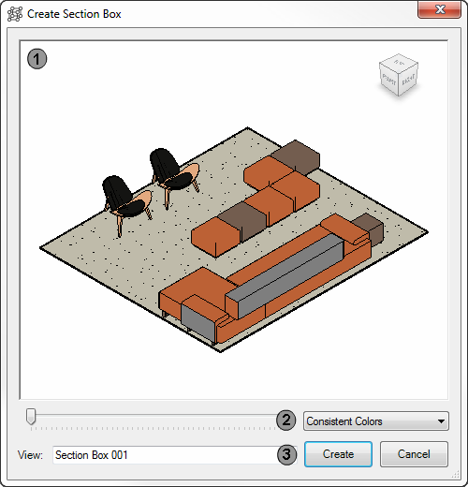

1. *Section Box Preview*  
     
   This gives a preview of what the expected section box will look like before it is created, the user can control the preview view in the following ways:

|  |  |
| --- | --- |
| Pan | Scroll Wheel Click and Drag Mouse |
| Rotate | Scroll Wheel Click + Ctrl and Drag Mouse |
| Zoom In | Scroll Wheel Up |
| Zoom Out | Scroll Wheel Down |

1. *Section Box Controls*  
     
   *Section Box Padding* - Alters the padding for the section box, shrink or expand the section box around the objects selected before the utility was started, preview will update to reflect changes automatically.  
     
   *Section Box Visual Style* – Sets the Visual Style that will be used when creating the section box, preview will update to reflect changes automatically.
2. *Utility Controls  
     
   Section Box View Name* Field – Sets the view name that will be created based on what is in the name field, it will automatically try to generate a viable name when first ran.  
     
   Create Button – Starts the section box creation process, duplicating the section box as per the preview.  
     
   Close Button – Closes the utility, the ESC key is linked to this button.

### Toggle Section Box

Single click script that toggles any section boxes on or off based on the active view within Revit.

### Purge Scope Box

The purge scope box utility is for cleaning up any used or unused scope boxes within the current active project when ran, the utility comes with the ability to filter the section boxes at the top of the dialog box.

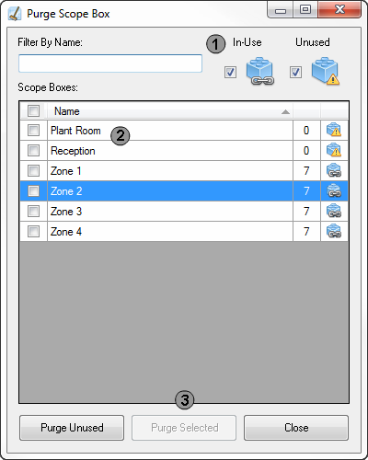

1. *Filter Controls*  
     
   Filters the scope boxes list based on name or if they are in-use or unused
2. *Scope Box List*  
     
   Displays all scope boxes within the current active project, it shows information about the scope box name, views the scope box is on and if it is used or not.
3. *Utility Controls*  
     
   *Purge Unused Button* – This will purge all unused scope boxes without having to select them from the scope box list.  
     
   *Purge Selected* – Purges only the checked scope boxes from the scope box list.  
     
   *Close Button* - Closes the utility, the ESC key is linked to this button.

### Export / Import Schedules

The Export / Import Schedule utility is used for converting schedules back and forth between Revit and Excel, so that users without Revit can edit the information externally and then run this utility to import the updated parameters.

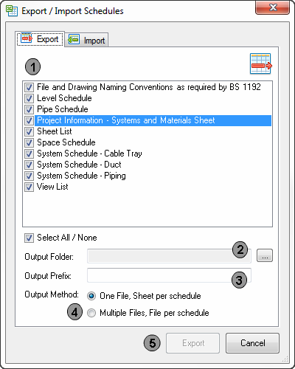*Export Schedules*

1. *Schedule List* – This list is populated by all schedules that can be found within the current active project, the user can select which schedules are to be added to the export process.
2. *Output Folder* – Required field for specifying the location of the exported files to be placed.  
     
   Folder selection button is located to the right side of the field that will allow easy folder selection for the user.
3. *Output Prefix* – Field for modifying the file names being exported out of the export process.
4. *Output Method* – Checkboxes used for specifying the output method, there are current two ways to output the schedules, either:  
     
   *One File, Sheet per schedule* – Export process will output each schedule selected from the schedule list as a new workbook sheet all within one excel workbook.  
     
   *Multiple Files, File per schedule* – Export process will output each schedule selected from the schedule list as a new excel workbook.
5. *Utility Controls*  
     
   Export Button – Starts the export process, using the output settings above.  
     
   *Cancel Button* – Closes the utility, the ESC key is linked to this button.

*Import Schedules*

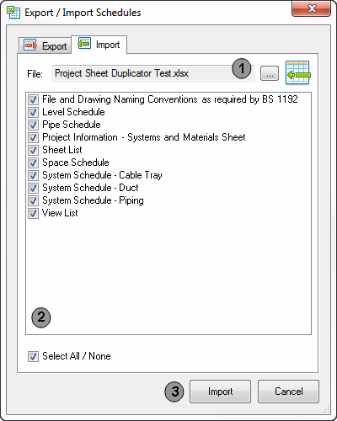

1. *C:\Users\coxm\Desktop\rpmBIMTools Guide\Notification_Information.pngImport File Selection* – This field is required to populate the schedule list below (2), once the user selects a valid excel file the utility will check if the schedules within it are compatible with the Revit schedules in the Revit project.  
     
   Schedules are compared between export and import processes by using Schedule and Element GUID’s
2. *Schedule List* – This list is populated with compatible schedules the user can select to add to the import process.
3. *Utility Controls*  
     
   Import Button – Starts the import process with the selected schedules in the list above.  
     
   Cancel Button – Closes the utility, the ESC key is linked to this button.

### Create LV Schematic

Utility to automate the creation of LV schematics using a massive collection of easy to understand user input controls and the ability to keep them compatible for import and export functionality.

The Create LV Schematic process does the following in order:

* Import any required missing family schematic symbols
* Creates drafting view with schematic name based on schematic name field
* Draws the schematic with symbols in predefined positions based on all the user fields entered before beginning the creation process.
* Creates a NGB sheet and places the schematic on it (if checked)
* Shows the finished schematic once the process is completed

The create LV Schematic utility is split into 5 sections on the user interface, below is each section with the main functions for each tab:

* Bus Section 1 – Controls for the creation of bus 1 with fields for adding a transformer and generator with position and data settings. Also includes a device field manager, allowing for complex circuit building with control over the device type, quantity, connected load and if the circuit is metered or not.
* Bus Section 2 – Same controls as bus 1 section (this bus is optional)
* Life Safety Section – Control the ability to add life safety supplies and the number of circuits.
* Extra Requirements – Controls for adding power factor corrections on either of the buses, also gives the option to include a large selection of schematic modifications via checkboxes. Some of the options can only be used if a bus has a transformer or generator (or both).
* Notes – Large collection of predefined notes that can be added to the schematic sheet, also gives the ability to create multiple custom notes for adding. This tab will only appear when a sheet is being created for the schematic.

### Import LV Schematic

Simple utility that recreates any LV Schematic from the exported xml file, utility will load any missing symbols that are required to building the schematic.

### C:\Users\coxm\Desktop\rpmBIMTools Guide\Export LV Schematic.pngExport LV Schematic

Scans the active Revit project for schematics and produces a list dialog box where the user can select a schedule to export to an xml file.

Schematics will only appear when created using the Create LV Schematic utility above or from previously imported schematic files.

Once a schematic has been selected the utility will prompt the user for a save location for the exported xml file.

### C:\Users\coxm\Desktop\rpmBIMTools Guide\Quick Select.pngQuick Select

The quick select utility is an advanced selection tool that gives the user filtering options on multiple data points in order to select the required elements.

1. *Select From* – Selection modifier based on the area the element is within, the following modifiers are as follows:   
     
   *Selected Elements* – This will only appear if elements were selected before running the utility.  
     
   *Current View* – This will tell the utility to search for elements only within the current active view in Revit.  
     
   *Current Project* – This will tell the utility to search for all elements within the active Revit project.  
     
   On the right side is a button for selecting a new set of elements in the current active view.
2. *Category* – Selection modifier based on the category the element is under, this drop down list is updated when the ‘Select From’ field is changed.
3. *Properties* – Filter modifier based on a single property selected by the user which is linked to the Property Type, Operator and Value fields below.
4. *Operator* – Field modifier that the user can select, this field will have different options based on the property type selected, it will always have the option to ‘Select All’, which as it states will disable the property field and will select all elements based on the ‘Select From’ and ‘Category’ fields only.
5. *Value* – Field modifier that the user can enter based on the property type and operator fields above, this field is also populated with the element property values found each time the property is changed, the values can be accessed by clicking the drop down arrow to the right of the field.
6. Selection Set Options – These controls allows the user to add the found elements to be added or removed from the current selection set.
7. *Utility Controls* – Starts the selection process or closes the utility using the control buttons at the bottom of the dialog box.

### Family Library

The family library gives access to NG Bailey’s family collection with a simple user interface and gives features that make finding the family they require quickly and hassle free.

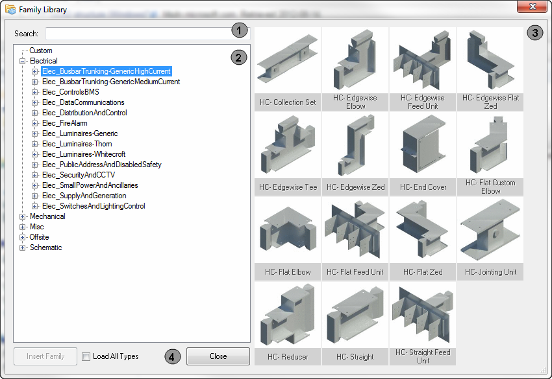

1. *Search field*  
     
   Search field is used by users to filter the family tree list (2) based on the text the user inputs in this field.
2. *C:\Users\coxm\Desktop\rpmBIMTools Guide\Notification_Information.pngFamily Tree List*  
     
   Shows all the families within the NG Bailey family collection, the tree is based on a 3 level structure:   
     
   - Service Name (Electrical, Mechanical, etc.)  
   - Service Type (Busbar, Fire Alarm, etc.)  
   - Family Files  
     
   Single clicking any level 3 node (family file) will update the selected preview icon to the right.  
   Double clicking any level 3 node (family file) will begin the insertion process for that family.
3. *C:\Users\coxm\Desktop\rpmBIMTools Guide\Notification_Information.pngFamily Preview Icons*  
     
   Previews all icons for the currently selected second level node in the family tree list, this set of icons is changed when the family tree list selection is altered or the search field is used.  
     
   Single clicking any family preview icon will update the selected family tree node to the left.  
   Double clicking any family preview icon will begin the insertion process for that family.
4. *Family Insertion Controls  
     
   insert Family Button* – Starts the insertion process, which can also be started by double clicking either the family in the family tree list or the famly preview icons.  
     
   *Close Button* – Closes the utility, the ESC key is linked to this button.  
     
   *Load All Types Checkbox* – Modifies the family insertion process in which it will skip the family type selection dialog and inserts all types that are contained within the family that was selected.

Family Insertion Process

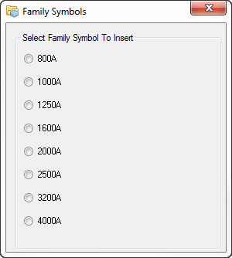Once a family is selected and the family insertion process has been started it will collect all the types that it has, if the family has more than one type the family symbol selection dialog box will appear (see right).

Once the user has selected a type from the dialog box Revit will begin loading all types or just the one selected based on the ‘load all types’ checkbox and then allow the user to insert into the current project using the hosting methods in the top ribbon.

C:\Users\coxm\Desktop\rpmBIMTools Guide\Notification_Exclamation.pngThe default placement ‘Place on Face’ can confuse users at times when trying to place within the project.

### Family Name Editor

The main function of the family name editor is to make the renaming of all families to a standard quick and easy and offering some automation in the process.

When the utility is ran it will scan the active project and begin checking all families to see if any are already compliant with either of the standards, when the scan is complete a user interface for the family name editor will appear, below is an example of the interface.

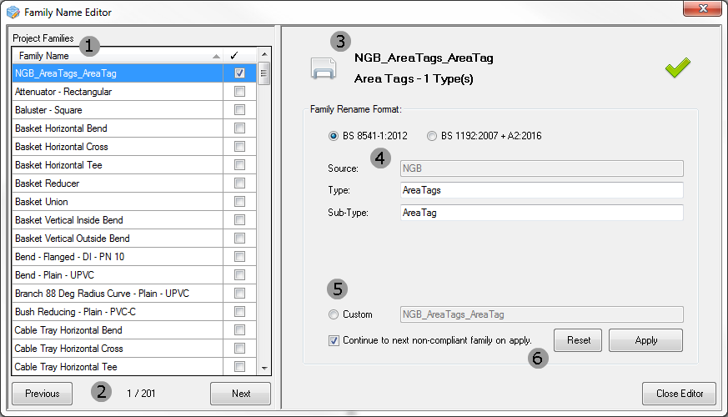

1. *Project Family List*This list contains a full collection of all families within the active project file, it has two visible fields, one being the family name and the other the compliance checkbox, the users task is to ensure that all the families in this list end up being checked as compliant by either of the standards detected automatically.
2. *Project Family List Controls*Simple previous and next controls with a counter that shows how many families are within the active project file.
3. *Selected Family Information*This information updates as the selected family on the Project Family List (1) changes, it shows basic information about the family which includes:  
     
   - Family Preview Image  
   - Family Name  
   - Family Category  
   - Number of Type(s) the family has
4. *Selected Family Renaming Format*  
     
   The fields in this section are updated based on the selected family on the Project Family List (1), at the top is the selection of which standard format is to be used, when the standard is changed the fields are altered.  
     
   The fields under this section will attempt to generate an approximate family name for the user to use; the fields can be changed before applying the changes in the Selected Family Controls. (6)
5. *Custom Family Renaming Field*  
     
   This field is used to rename a family outside of the two standards available; this will not follow the standard and will not be checked as compliant in the Project Family List. (1)

*Selected Family Controls*  
  
Controls used to control the currently selected family, they are:  
  
*Reset Button* - Resets the fields in the Selected Family Renaming Format (4) section if they were edited before applying.  
  
*Apply Button* - Renames the currently selected family in the Project Family List (1) to the standard or custom format based on standard selection and fields within the Selected Family Renaming Format (4) section.  
  
*Continue Checkbox* – This checkbox is linked with the apply button, when the apply button is used and this checkbox is checked it will automatically move the Project Family List (1) to the next non-complaint family.

### C:\Users\coxm\Desktop\rpmBIMTools Guide\Generate GUID.pngGenerate GUID

This is utility is a simple click and generate function that will produce random 32 bit alphanumeric GUID’s (Globally Unique Identifier).

The utility gives the option for an ‘All Caps’ modifier, which does what it stated.

Below are a few examples of random GUID’s that are generated by this utility:

* baba18bf-9b14-4384-9ebc-ceac69edd008
* 814618d5-38c3-4341-a7fd-fb359a1139ab
* C:\Users\coxm\Desktop\rpmBIMTools Guide\Notification_Information.png738c5019-177a-40be-bdf7-1dab5b66b916

This utility generates GUID’s based on version 4 and confirms to RFC 4122 specification.

### Bulk File Updater

This utility is still under development.

# Ribbon Extensions

Text Notes Special Character Insertion

# Additional Resources

### Video Tutorials

Video Tutorials are still under development and need to be created, ASAP!!!!  
Will store all under a YouTube channel or something else.

### Github

The rpmBIMTools Repository for the Visual Studio Solution can be located at the following URL:

[https://github.com/mcox86/rpmBIMTools](https://github.com/mcox86/rpmBIMTools%20)

Please use this site to report any issues with the utilities so fixes can be resolves in a documented and efficient manner.

### Developer API Calls

Below is a list of all the API calls that rpmBIMTools supports to call them from another namespace.

|  |  |
| --- | --- |
| **Utility** | **API Class Call** |
| Project Setup | rpmBIMTools.projectSetup |
| Project Sheet Duplicator | rpmBIMTools.projectSheetDuplicator |
| Drawing Number Calculator | rpmBIMTools.DwgNumCalc |
| Model Export | rpmBIMTools.exportModel |
| Create Section Box | rpmBIMTools.createSectionBox |
| Toggle Section Box | rpmBIMTools.toggleSectionBox |
| Purge Scope Box | rpmBIMTools.purgeScopeBox |
| Export / Import Schedules | rpmBIMTools.exportImportSchedules |
| Create LV Schematic | rpmBIMTools.createLVSchematic |
| Import LV Schematic | rpmBIMTools.importLVSchematic |
| Export LV Schematic | rpmBIMTools.exportLVSchematic |
| Quick Select | rpmBIMTools.quickSelect |
| Family Library | rpmBIMTools.familyLibrary |
| Family Name Editor | rpmBIMTools.familyNameEditor |
| Generate GUID | rpmBIMTools.generateGUID |
| Bulk File Updater | - |